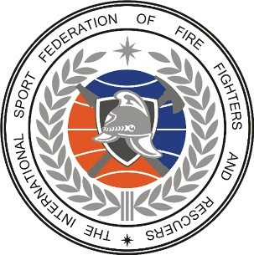
XXIV INTERNATIONAL CONFERENCE
October 25-29, 2023, Harbin (the People’s Republic of China)

Country _____________________________

№ | Mr/Mrs | Last name/First name | Nationality | Date of birth | Passport No. | Date of arrival / departure | Position and place of job
 |  |  |  | Place of birth | Date of expiry | Vehicle
1
2
3
4
5

Contact address:
Phone number:
E-mail: ‏ ‬‏‬‬‬‬‬‬‬
Date:

Stamp and signature

